# Exercise: Integration Testing of Web API Controllers

This document defines the exercises and homework assignments for the   
**"QA Back-End Test Automation" Course @ SoftUni.**

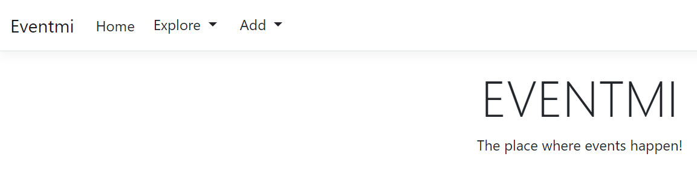

## Preparing the Development Environment

Before diving into exploring the application and understanding its structure, it's crucial to ensure that your development environment is properly set up.

### Connect Visual Studio with SSMS

Launch **SSMS** and connect to your **SQL Server** instance. Ensure that you have the necessary permissions to create and modify databases. Note down the connection details (server name, authentication method, etc.) for establishing a connection from **Visual Studio**.

### Update the Database

Review the database configuration in the ASP.NET MVC project's **appsettings.json** file. Ensure that the **connection string** is correctly configured to connect to your **SQL Server** instance. Use **Entity Framework Core** **migrations** to **create or update the database schema.**

* Open **Package Manager Console** in Visual Studio   
  (Tools > NuGet Package Manager > Package Manager Console)
* Run the following command to apply migrations and update the database: **Update-Database**

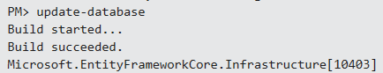

* This command will **apply any pending migrations and update the database** schema accordingly

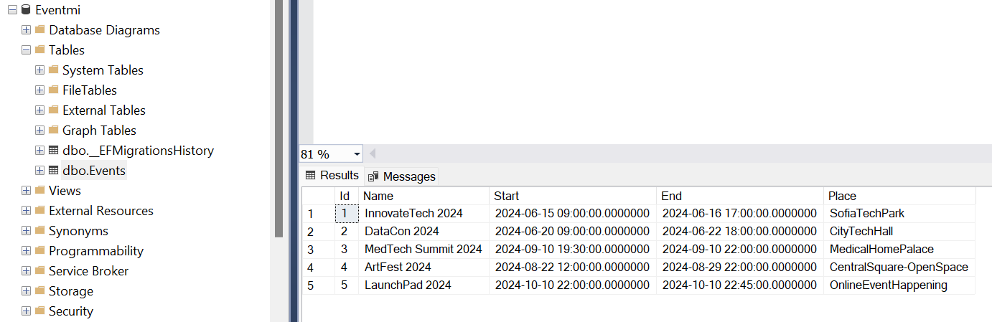

## Discovering the Application

Before diving into testing with **RestSharp**, it's essential to understand the structure and **functionality** of the ASP.NET MVC project, particularly **focusing on the EventController** and its associated views. Here's what you need to know:

### Purpose of the Application

The **Eventmi** application serves as a comprehensive platform designed to facilitate the management of events.

### Understanding Controller Actions

In **ASP.NET MVC**, **controllers play a central role in handling incoming HTTP requests**, **processing data**, and **generating responses**. Controllers are responsible for **executing the application logic** and determining which **views to render**. Let's dive deeper into understanding controllers in the context of our Eventmi application.

* **Definition**: A controller is a C# class that **inherits from the Controller base class** or **implements** the **IController** interface. It typically resides in the Controllers folder of the project
* **Responsibilities**:
  + Handle incoming HTTP requests from clients
  + Process and validate data
  + Interact with the model layer to retrieve or update data
  + Determine the appropriate view to render and pass data to the view
* **Actions**: An action is a public method within a controller that corresponds to a specific HTTP request. Each action is responsible for processing a particular request and generating an appropriate response

### Functionality Overview

Review the functionalities provided by the **EventController**. This includes **adding**, **editing**, **deleting**, and   
**viewing** events.

* **Adding Events**
* The **Add action** within the EventController enables users to **add new events to the application**
* It **renders a view** where users can input details such as the event title, date, time, location
* Upon **form submission**, the controller **processes the input data** and  
   **initiates the creation of a new event**

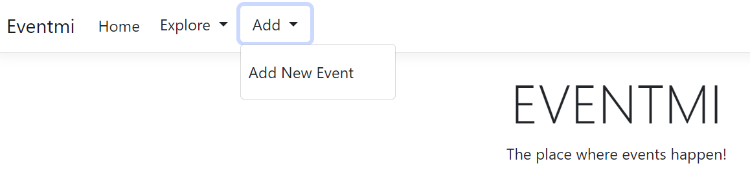

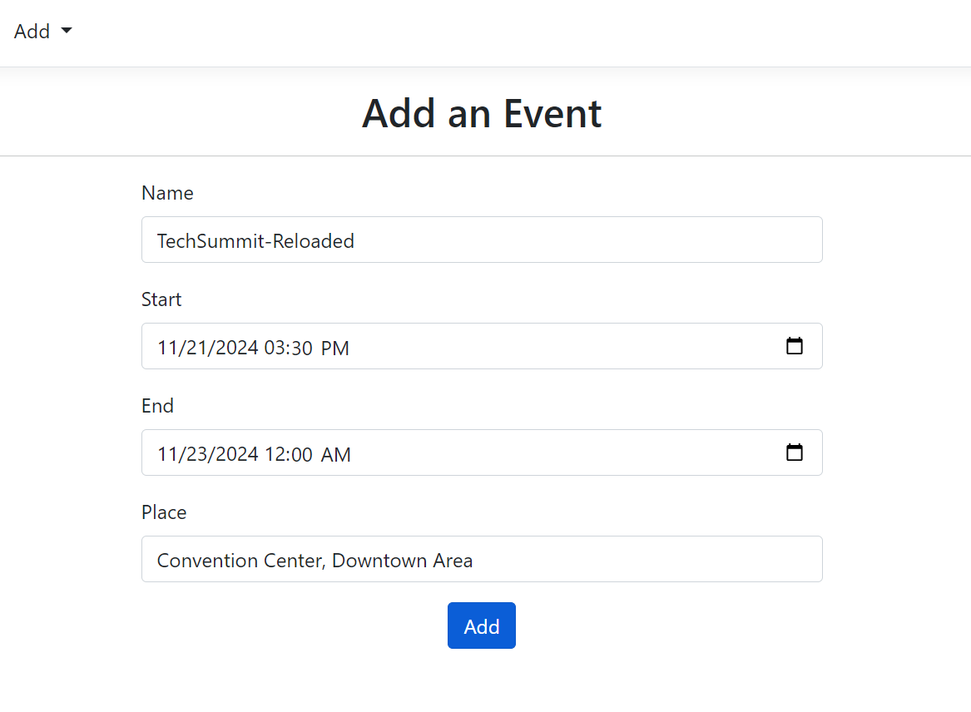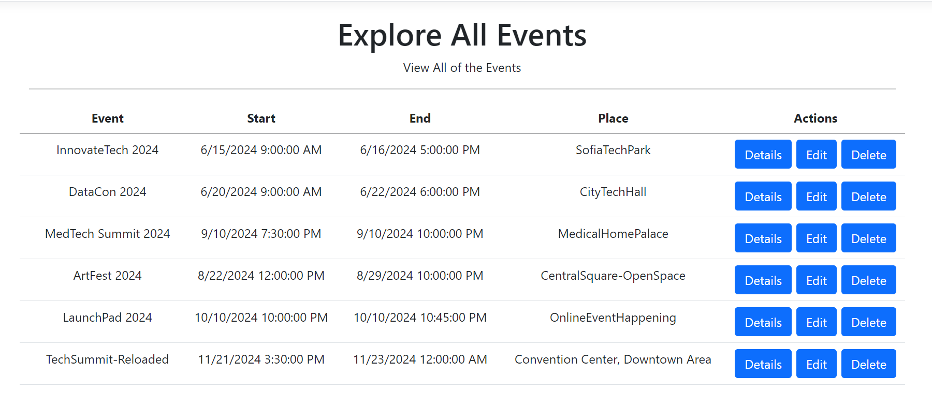

* **Viewing All Events**
* The **All action** retrieves and **displays a list of all events** currently available in the system
* Users can **access this list** to browse through the various events hosted on the platform
* Each **event listing typically includes essential details** such as the event name, start date and time, end date and time, and information about the location that will take place

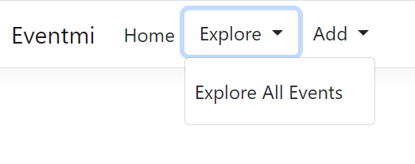 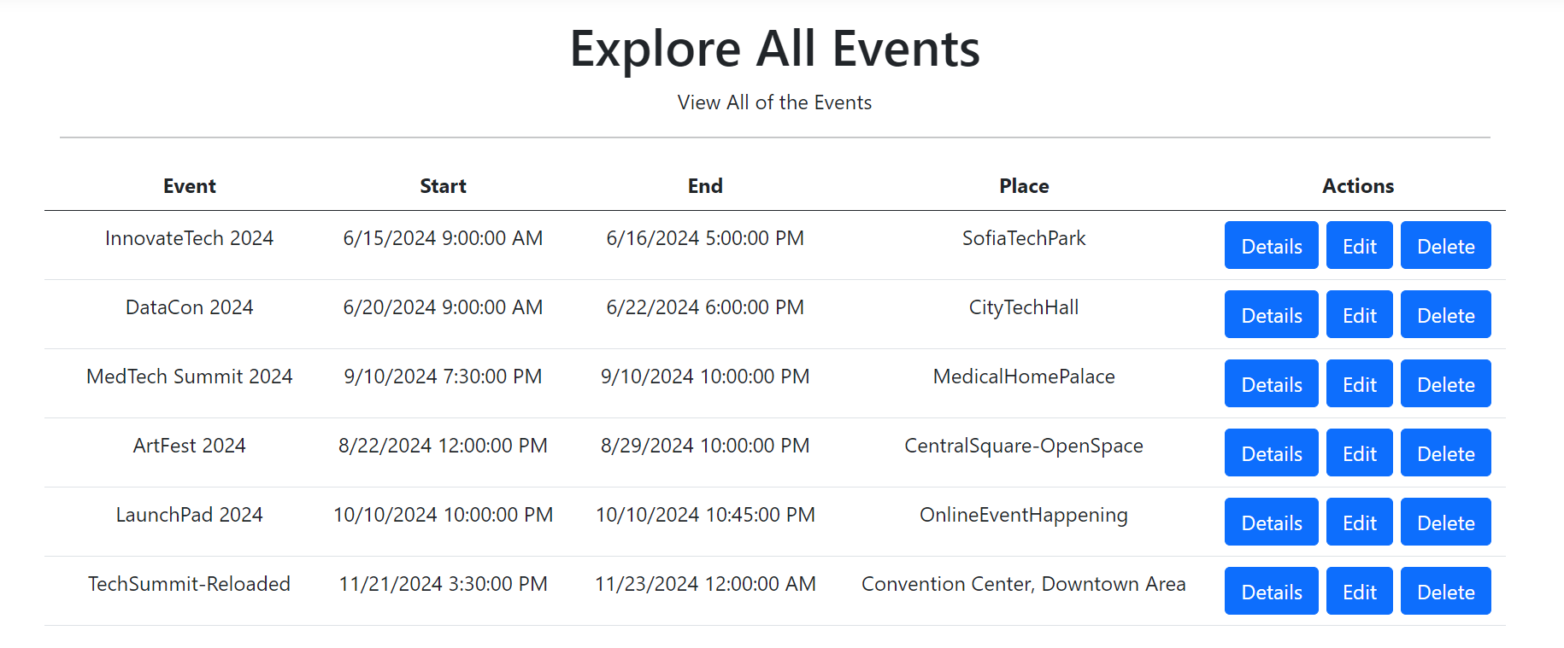

* **Viewing Event Details**
* The **Details action** allows users to view detailed information about a specific event
* Users can **access the details page of an event** by clicking on the **Details button** or associated link
* The **controller retrieves the complete set of information** associated with the event and **renders it** on a dedicated details view

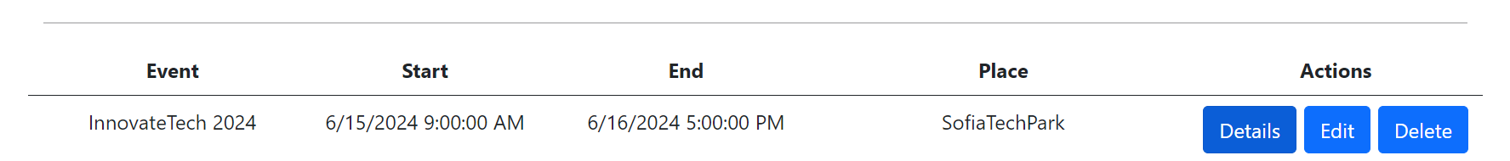

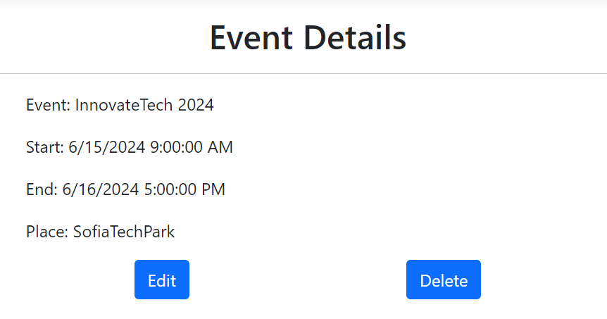

* **Editing Events**
* The **Edit action** allows users to **modify existing events**
* Users can access an **edit form pre-populated with the current details** of the event they wish to modify
* After making the necessary **changes**, users **submit the form**, **triggering the controller to update the corresponding event** with the revised information

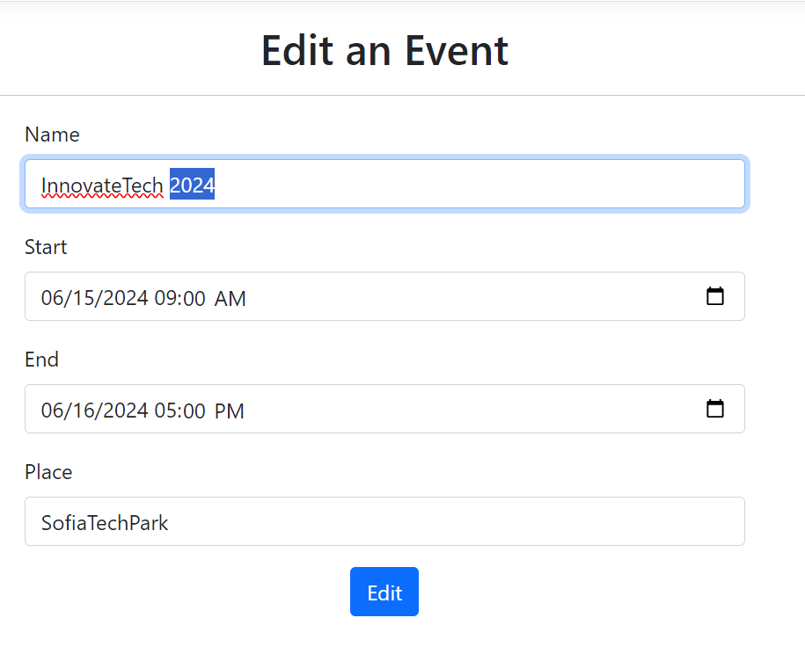

* **Deleting Events**
* With the **Delete action**, users can **remove events from the application**
* Typically, **this action is triggered by clicking a delete button** or **link associated with a specific event**
* Тhe **controller initiates the deletion process**, permanently removing the event from the system



### View Templates

Explore the **views associated with the EventController actions**. These views are **responsible for rendering HTML** content to the users.

In **ASP.NET MVC**, adopting consistent **naming conventions** for views helps maintain a clear and organized project structure. By following naming conventions, developers can easily locate and identify **views related to specific controllers or actions**.

Views are typically **organized in folders** that **correspond to the controller names**. Within each controller folder, views are further **organized into subfolders** named after the **controller's actions**. This convention helps group related views together and makes it easier to locate views for specific controller actions.

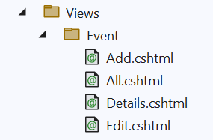

### Data Model

Examine the **data model associated with events**.

* What attributes does an event have?
* How is event data stored and retrieved?

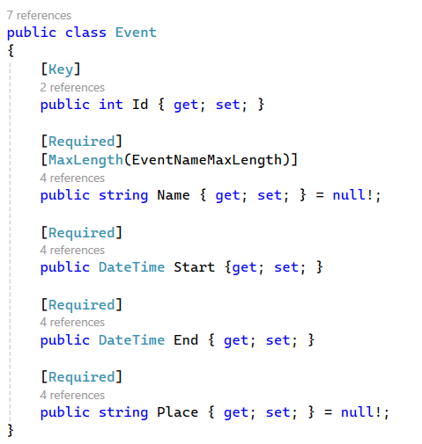

### Dependencies

Identify any **external dependencies the controller relies on**, such as services or data access layers.

### User Workflow

Understand the typical **user workflow within the application**.

* How do users interact with events?
* What actions can they perform?

By gaining a **comprehensive understanding of the application**, you'll be better equipped to design and execute **meaningful tests using RestSharp**. This knowledge will guide you in writing test cases that cover **critical aspects of the application's functionality**, ensuring its **reliability** and **correctness**.

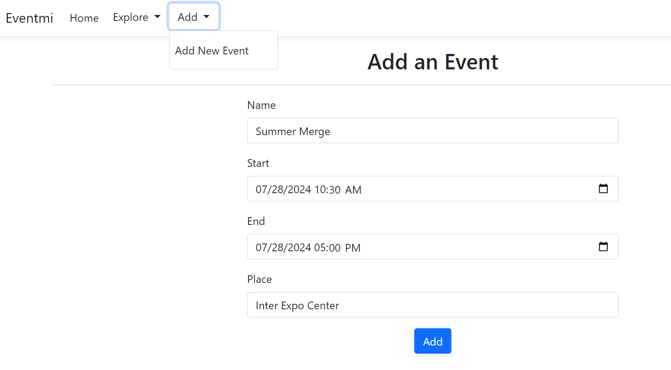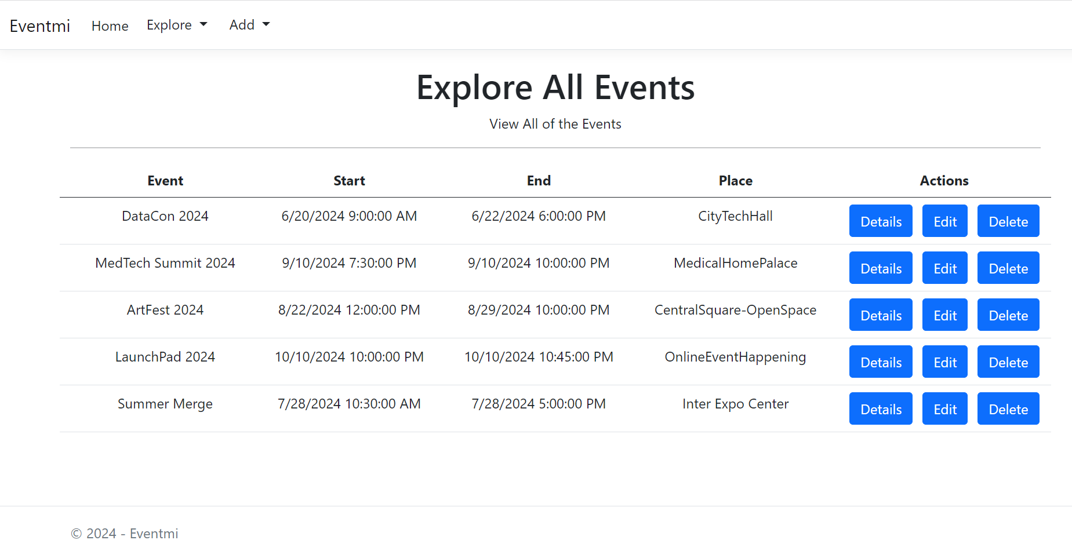

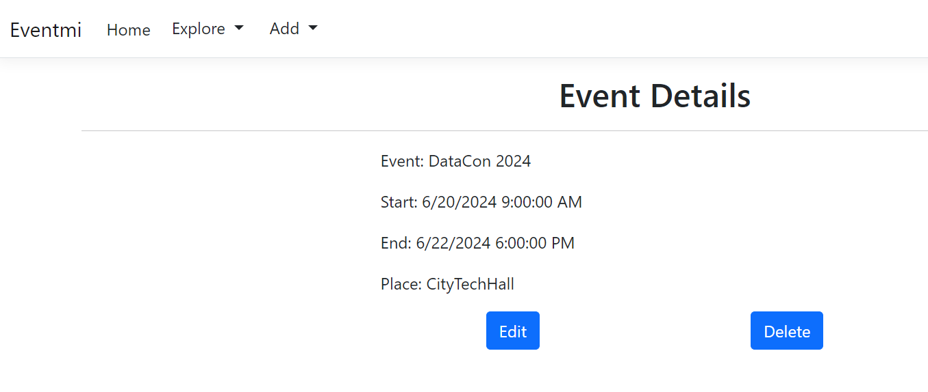

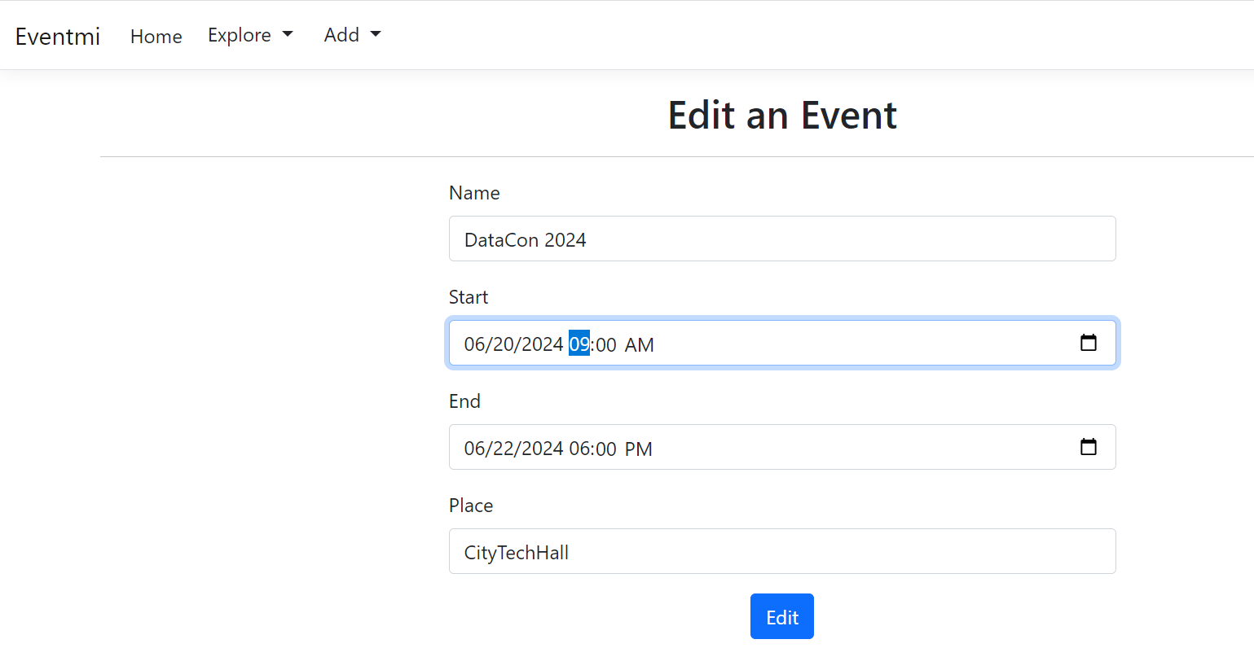

## Setup RestSharp in your ASP.NET MVC project

### Create a New Test Project

* Right-click on your **solution** in Visual Studio
* Select "**Add**" > "**New Project**" from the context menu
* **Choose** the appropriate **project template** for your test project (e.g., **NUnit**)
* Ensure that the **.NET version matches your main ASP.NET MVC project** (e.g., .NET 6.0).
* Give your project a name (e.g., **Eventmi.Tests**) and click "**Create**"

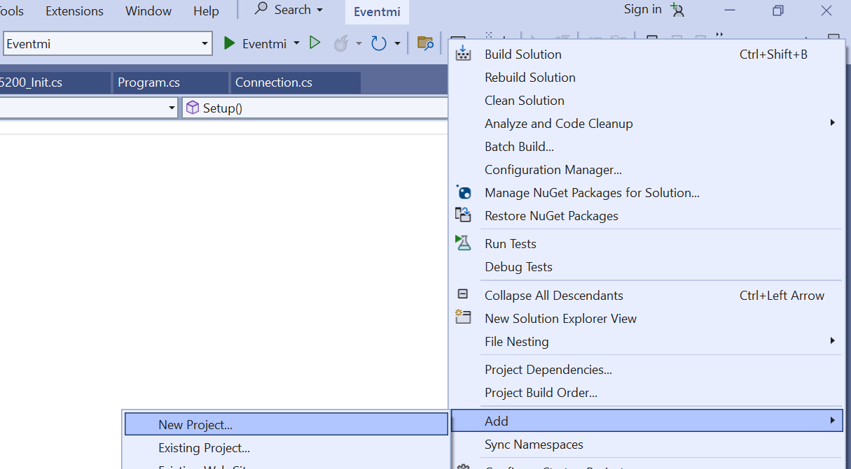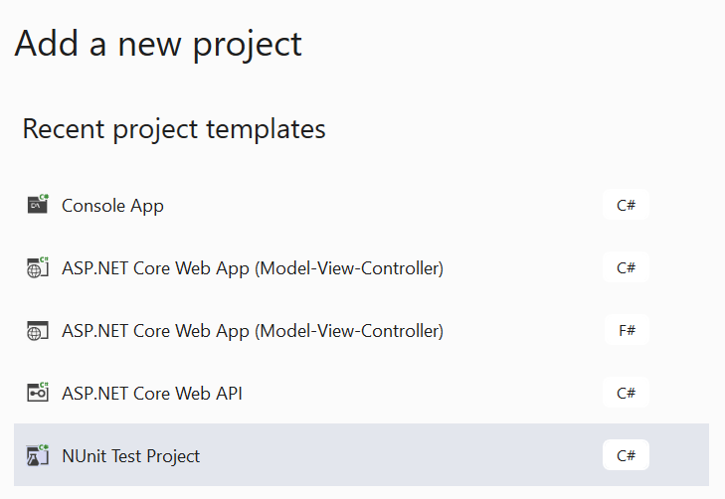

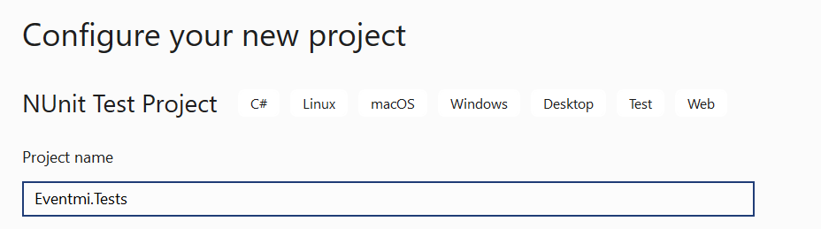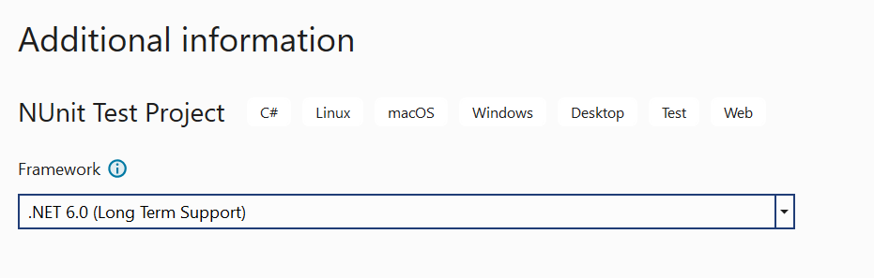

### Add Project Reference

* Right-click on the test project in the Solution Explorer
* Select "**Add**" > "**Project Reference**" from the context menu
* In the "**Reference Manager**" window, select the "**Projects**" tab
* Check the checkbox next to the main ASP.NET MVC project to **add a reference to it**
* Click "**OK**" to confirm and add the reference

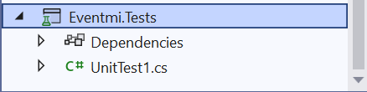

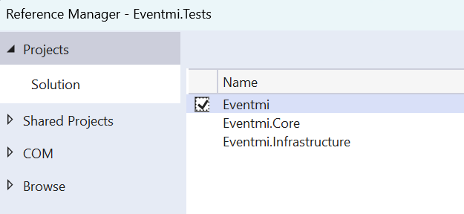

### Add Dependencies

* Right-click on the test project in the Solution Explorer
* Select "**Manage NuGet Packages**" from the context menu
* Install the **RestSharp package** by searching for "RestSharp" and installing it

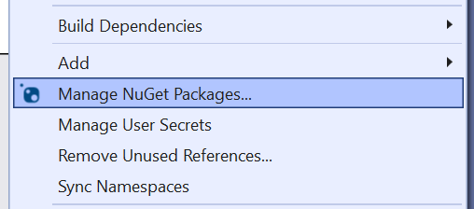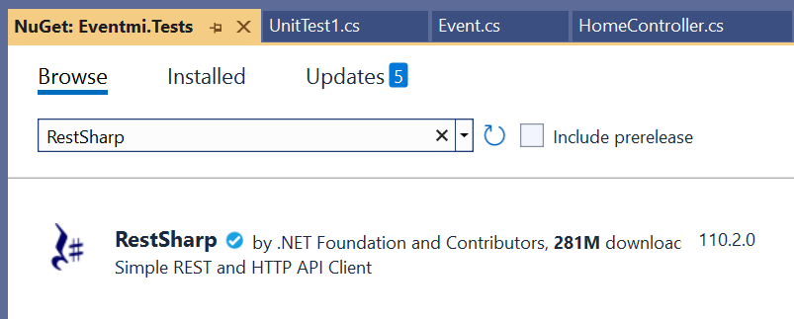

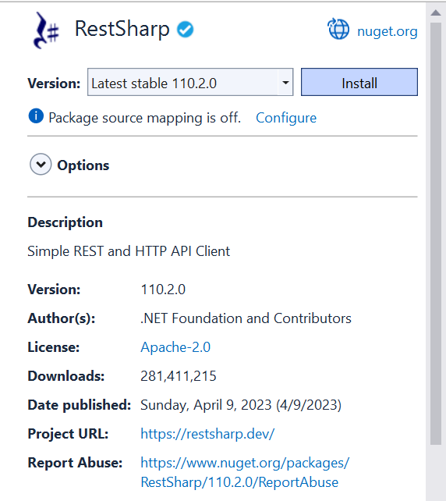 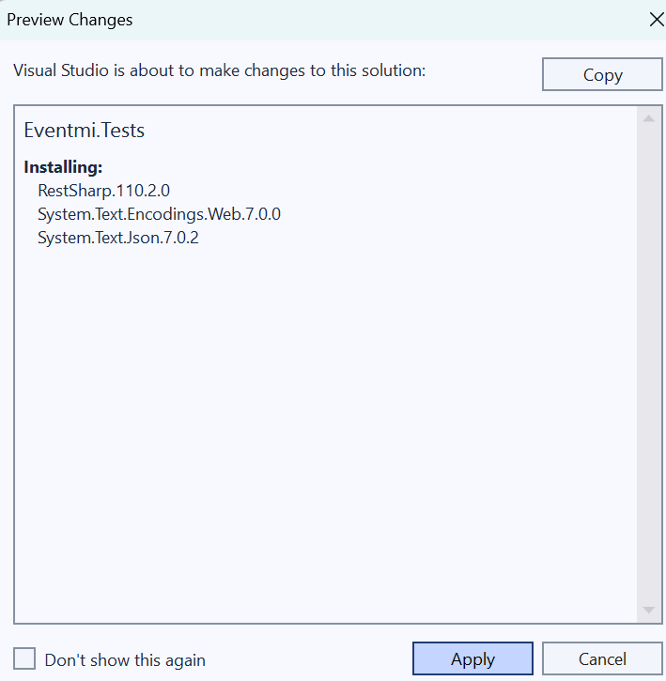

### Why Adding Dependencies is Important

Adding dependencies, such as testing frameworks and RestSharp, ensures that **your test project has access to the required tools and libraries** for writing and executing tests effectively. These dependencies provide the necessary functionality to **simulate HTTP requests**, **assert behavior**, and **validate results** during testing.

**Note:**

* Ensure that you install **compatible versions** of the dependencies that are **supported by your test framework** and target .NET version.
* **Keep dependencies up to date** by periodically checking for updates and installing the latest versions to leverage new features and improvements.
* By adding the necessary dependencies to your test project, you equip it with the **tools and libraries** required to write comprehensive tests for your ASP.NET MVC application, ensuring its functionality and reliability.

## Writing Test Cases

* Open the test class **corresponding to your controller** in the test project
* Write test methods to **verify the behavior of the controller actions**
* In the test methods, **use RestSharp to simulate HTTP requests** to the controller and **validate the responses**

### Create a New Class in the Test Project

* **Right-click** on the **test project** in the Solution Explorer
* Select "**Add**" > "**Class**" from the context menu
* **Name the class appropriately**, such as **EventControllerTests.cs**
* Click "**Add**" to create the class

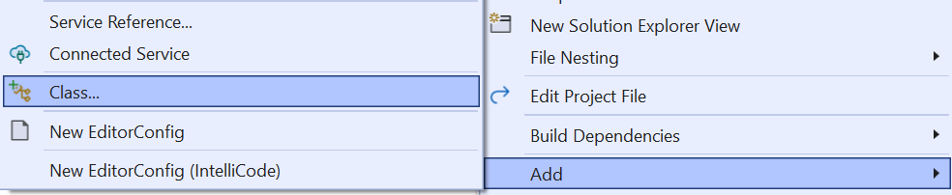

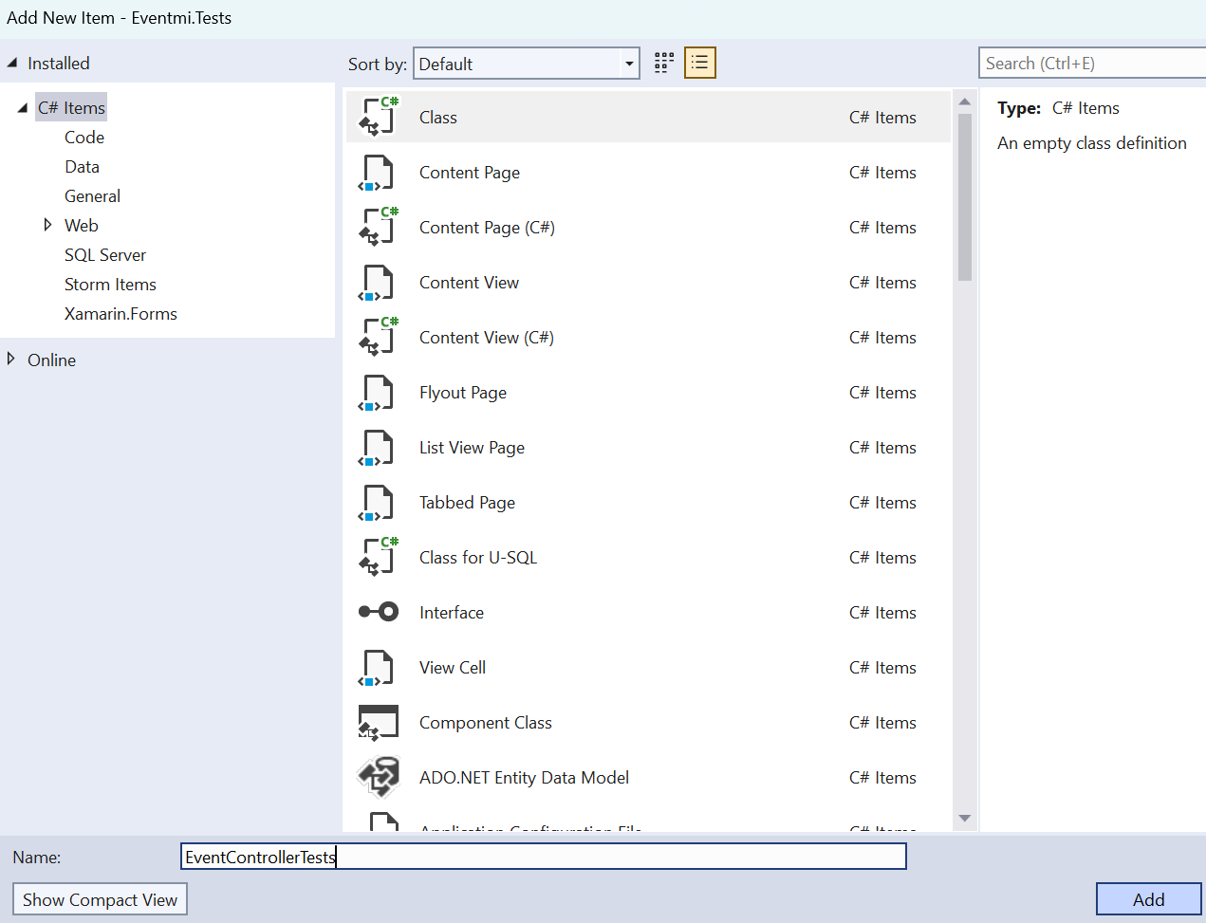

### AAA Pattern

In the newly created class (**EventControllerTests.cs**), you'll write test methods to **verify the behavior of the EventController actions**. Each test method should follow the **Arrange-Act-Assert pattern**

* **Arrange**: Set up any necessary pieces before executing the code you're testing. This could include creating mock data, **configuring a RestSharp client**, and setting up request objects
* **Act**: Execute the action that you're testing. This will typically be a **call to the controller action via RestSharp**
* **Assert**: Check that the action has had the expected outcome. This can include **verifying the status code**, **the data returned**, and that **certain methods were called**

### Initialize Reusable Fields

**private RestClient client:**

* This field holds an **instance of the RestClient** which is part of the RestSharp library
* The **RestClient is responsible for sending HTTP requests** and **receiving responses from your API**
* It is **declared as private** because it **should only be used within the EventControllerTests** class and not be accessible from outside

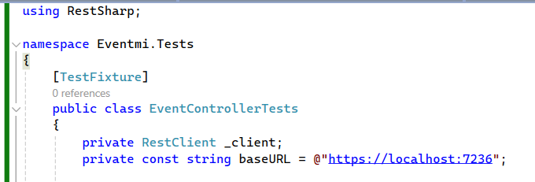

**baseURL:**

* In the context of testing an API using RestSharp refers to the **root address where the API is accessible**
* When you instantiate a **RestClient object**, you provide it with this base URL, and it will be used as the **starting point for all requests** made by that client
* If your API is running locally and **listening on port 7236**, your base URL might be "**https://localhost:7236**"

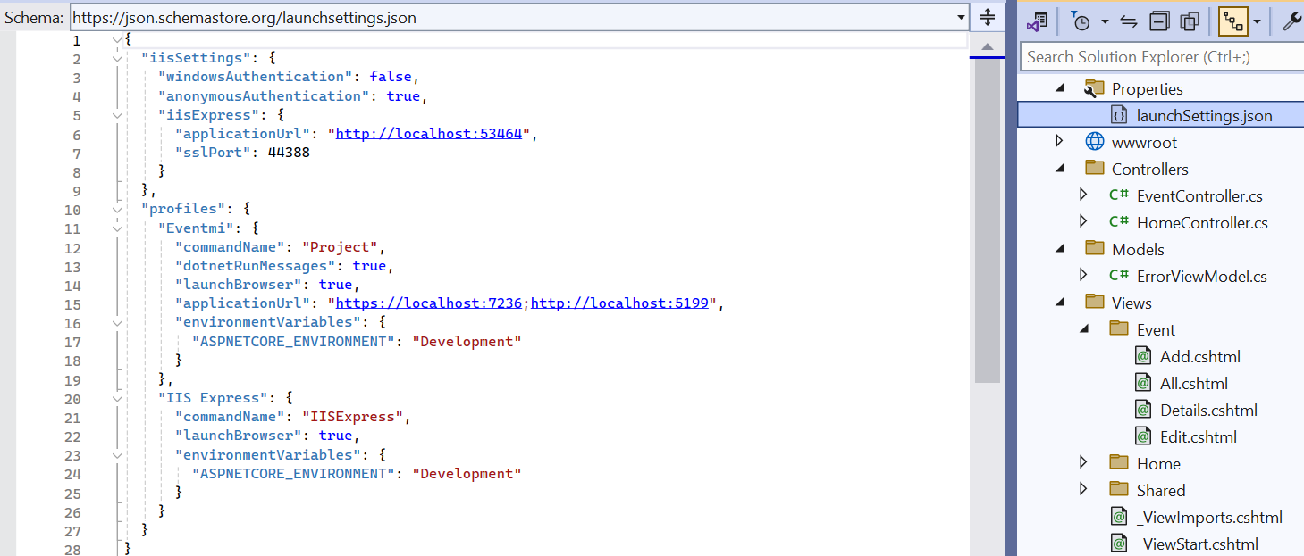

### [SetUp] Method

Instead of a constructor, the **[SetUp]** method is used in NUnit to prepare the test environment before each test is run.

* **RestClient Initialization**: The **_client** field is **assigned a new instance of RestClient**, which is **initialized with** the **baseURL field**. This RestClient instance will be used to **send HTTP requests to your API**

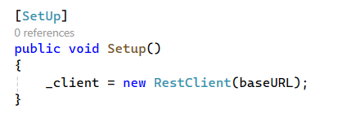

### Why Not Use a Constructor?

While you could theoretically use a constructor in a test class to initialize fields, it's not the standard practice for a few reasons:

* **Consistency**: NUnit's setup and teardown methods (**[SetUp]** and **[TearDown]**) provide a consistent way to initialize and **clean up resources before and after each test**. They're designed to work with NUnit's test lifecycle
* **Flexibility**: Using **[SetUp]** **allows for more complex setup logic** that might involve reading from configuration files, setting up mocks, or any other actions you'd want to perform before each test.
* **Isolation**: **[SetUp]** **ensures that the state is reset before each test**, providing better test isolation and reducing the risk of inter-test dependencies.
* By following the [SetUp] convention, your **tests become more predictable** and easier to understand for anyone familiar with NUnit.

### Write Test Methods

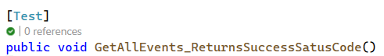

The name of the test method, **GetAllEvents_ReturnsSuccessStatusCode**, is designed to be **self-explanatory**, indicating both **the action being tested** and **the expected outcome**.

Breaking down the name:

* **GetAllEvents**: This suggests that the **test is focused on the functionality that retrieves all events**. It implies a **specific action or endpoint in your API** that is **responsible for returning a collection of event objects**
* **ReturnsSuccessStatusCode**: This part of the name specifies the **expected result of the test**. It indicates that, **upon invoking the GetAllEvents action**, the **API should respond with a success status code**, which is typically **200 OK** in HTTP terms. This status code signifies that the request was successfully processed

Arrange

* In the arrange section, you prepare the necessary setup for executing the test.
* **RestRequest object is created** with the endpoint **/Event/All** and the **HTTP method GET**.
* This setup involves specifying **which API endpoint you're testing** and **the type of HTTP request made**.



Act

* The act section is **where the action being tested is performed**.
* In this case, it's the execution of the **HTTP request against the specified endpoint**.
* By executing the request, you're simulating what would happen when this **endpoint is called under   
  normal circumstances**.



Assert

* The assert section **verifies** that the **outcome of the action meets the expectations**.
* For this test, the **expectation is that the API will return a 200 OK status code**, indicating success.



## Running Tests

### Configure Multiple Startup Projects

* Right-click on the solution in Visual Studio
* Select "**Properties**" from the context menu
* In the properties window, navigate to "**Common Properties**" > "**Startup Project**"
* Select "**Multiple startup projects**"
* Set the action for both your **ASP.NET Core MVC Eventmi project** and your **Eventmi.Tests** **project** to "**None**"

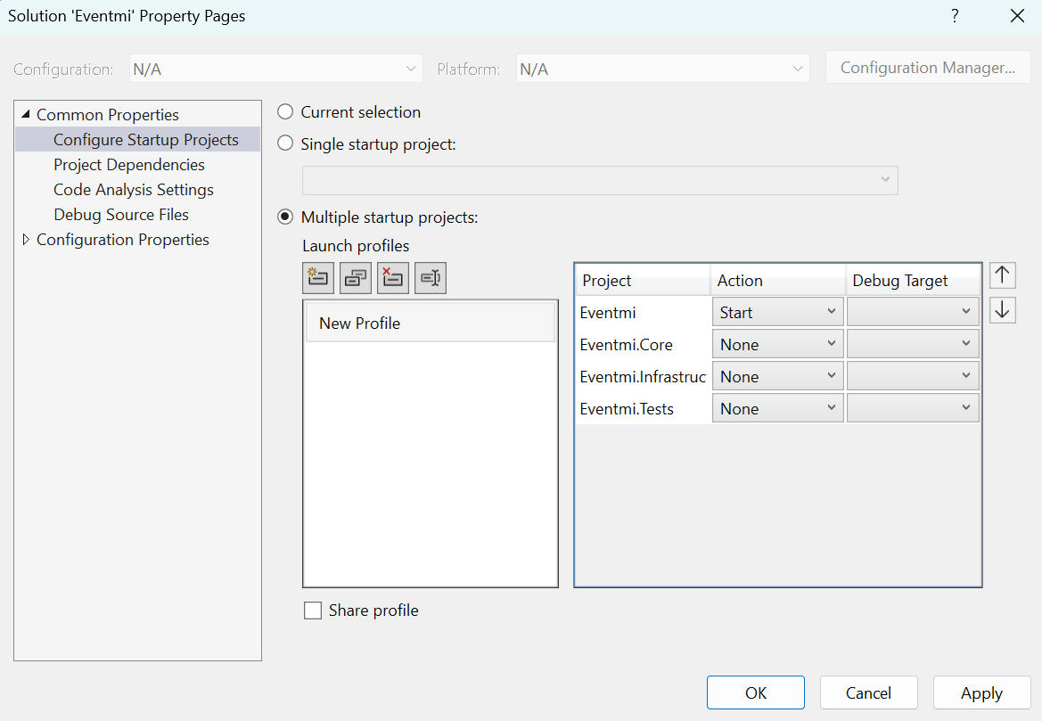

### Start the API

Use "**Start Without Debugging**" (**Ctrl+F5**) to **launch the API**. This will start the API without attaching the debugger, freeing up Visual Studio to do other tasks like running tests.

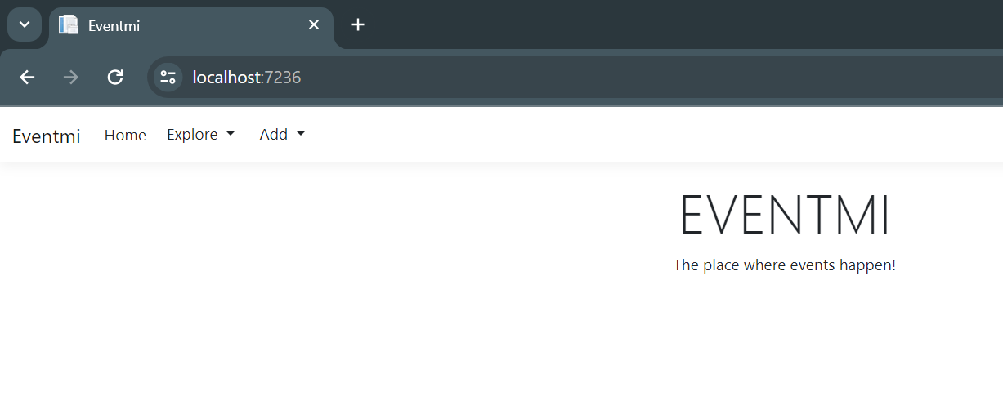

### Run Tests

* Open the Test Explorer by going to "**Test**" > "**Test Explorer**" in the menu bar
* You can now run your tests manually by clicking "**Run All**" or **selecting specific tests to run**.
* This does not require the debugger, so **it can be done while the API is running**

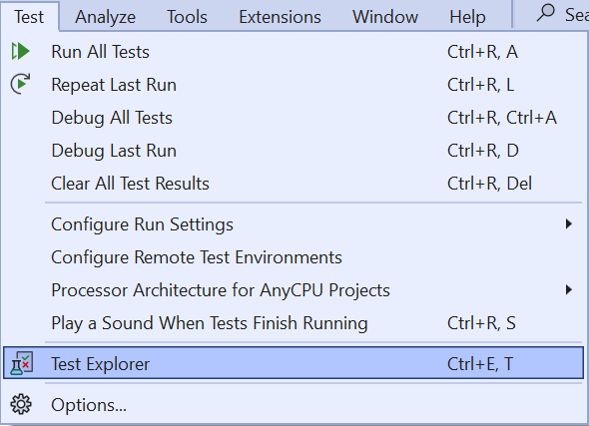

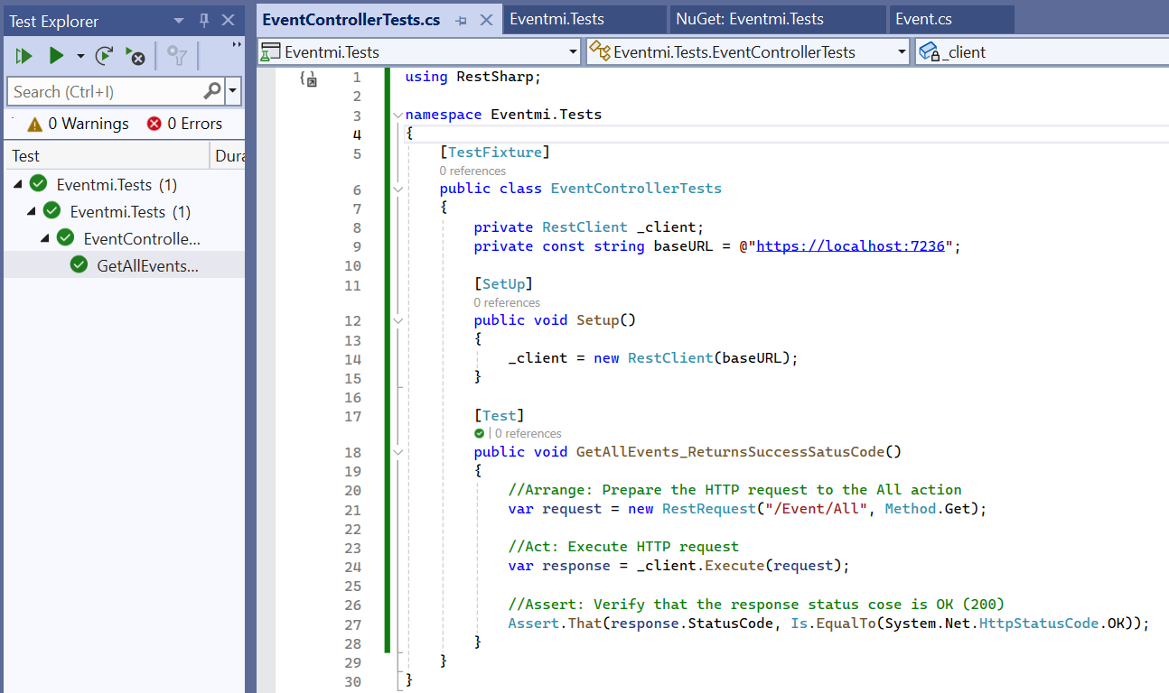

### Attach to Process for Debugging

* If you need to **debug the API**, you can use the "**Attach to Process**" feature.
* Go to "**Debug**" > "**Attach to Process**" and **select your running API process**.
* This will allow you to **attach the debugger to the running process without stopping it**

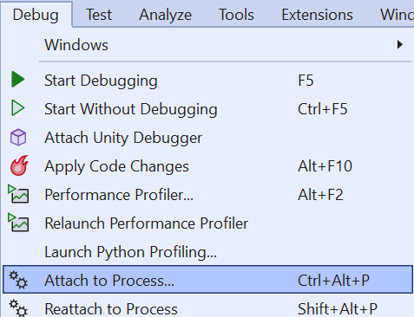

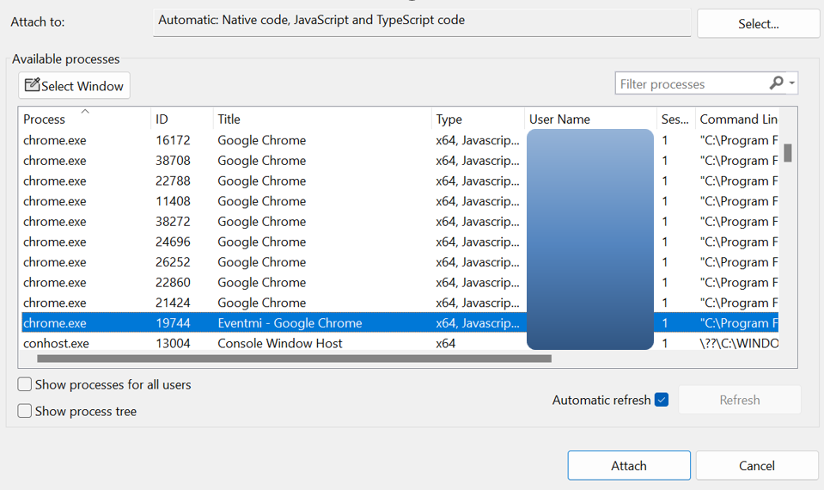

## Testing of EventController Endpoints

This section will guide you through the process of **creating tests for each endpoint in the EventController**. We'll cover how to **structure your tests to ensure they are comprehensive**, **readable**, and **maintainable**. The goal is to **achieve high coverage of the controller's functionality**, ensuring every aspect of the **API's behavior is validated.**

### Testing "Add" Action (GET Request)

This test will **verify** that the **Add view** is **returned correctly when navigating to the add event page**

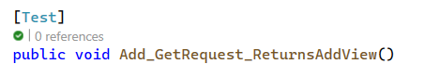

* **Arrange Phase**:

**Creating a RestRequest**: The first step involves **setting up the test environment** and **preparing the HTTP request**. Here, a **RestRequest object is created with the path "Event/Add"** and the **method Method.Get**. This object represents an **HTTP GET request** directed at the **/Event/Add endpoint** of your application, which is the URL path that users would visit to add a new event.



* **Act Phase:**

**Executing the Request**: The prepared **request is then sent to the server** using **_client.Execute(request)**. The **_client** here is an **instance of RestClient initialized with the base URL** of your application, allowing it to make HTTP requests. This step **simulates what happens when a user navigates to the "Add Event" page in a web browser**.

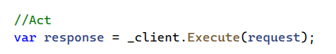

**Assert Phase**:

**Verifying the Response**: The final step is to **verify the outcome of the request**. The assertion checks that the **HTTP status code in the response is 200 OK**. This status code indicates that the request was successful, and the server has responded with the web page content where users can add a new event.

### Testing "Add" Action (POST Request)

This test demonstrates how to perform an **integration test** that not only **sends a request to a web application** to add a new event but also **verifies that the event has indeed been added to the database**.

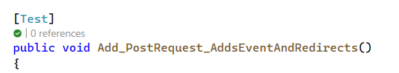

* **Setup Request with RestSharp**

First, we create a new **EventFormModel** instance with the event details we want to add. This model mirrors what the web application expects to receive from a form submission

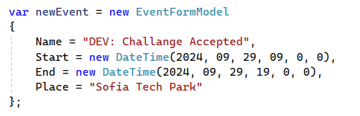

Then, we prepare a RestRequest to send to the **/Event/Add endpoint**

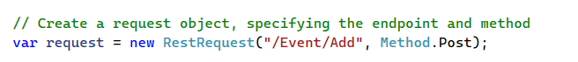

We specify that the request will use   
**x-www-form-urlencoded** content type, which is typical for form submissions



We add **each property** of our EventFormModel **as a parameter to this request**

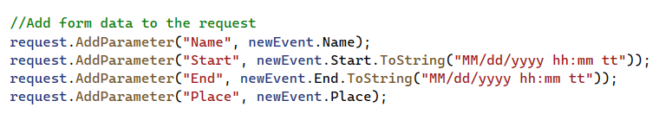

* **Execute the Request**

We use a **RestSharp client to send the request to the web application** and capture the response

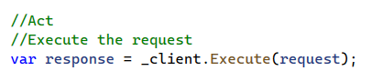

* **Assert the Response**

First, we **check the HTTP status code of the response to ensure it's 200 OK**, indicating the request was   
successfully processed



* **Verify Database Addition**

Finally, we **verify that the event has been added to the database**.

We define a **CheckEventExists** method that creates a **new DbContext instance** with the **appropriate options to connect to our database**. Using this context, we query the Events table (or whichever is appropriate) to check if an event with the specified name exists

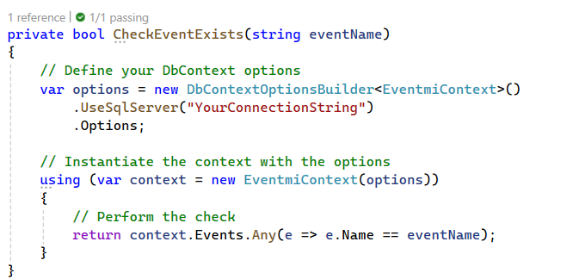

**And then we use this method in our test assertion**



* **Verify the existence of a new event in your database using SQL Server Management Studio**

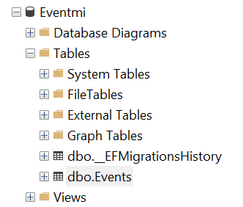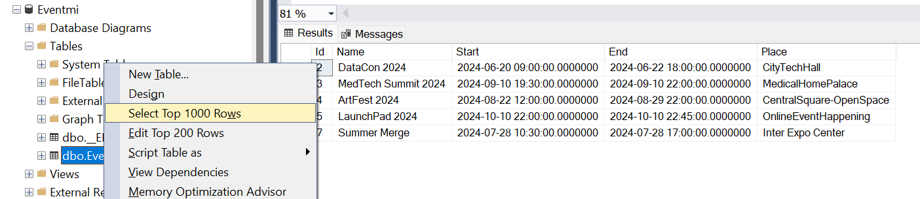

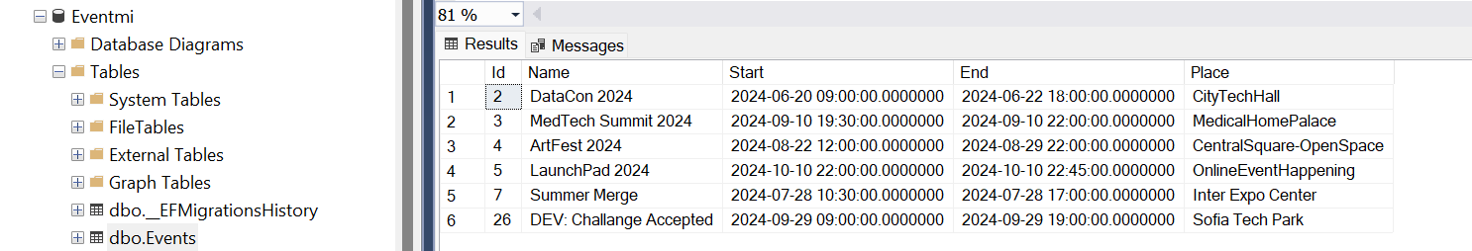

### Testing "Details" Action (GET Request)

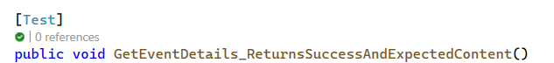

* **Arrange Phase:**

Declare and initialize the variables needed for the test.

Here, **eventId** represents the **ID of an event** you want to retrieve details for. It's set to 1 for this test, implying you're expecting to find an event with this ID in your database.



The RestRequest object is configured to make a GET request to the **/Event/Details/{eventId} endpoint**, where **{eventId}** is a placeholder for the actual event ID.



* **Act Phase:**

Execute the operation or method being tested

This is where you **send the HTTP GET request** to the server using the **configured** **RestRequest object**. The Execute method of the **_client** (an instance of RestClient pointed at your API) sends the request to the endpoint and waits for the response. This mimics what happens when a user tries to access the details page of an event in a web application



* **Assert Phase:**

Verify the outcome of the Act phase against the expected result.

After receiving the **response from the server**, this phase checks if the **HTTP status code of the response is 200 (OK)**. This status code confirms that the request was successfully processed



### Testing "Edit" Action (GET Request)

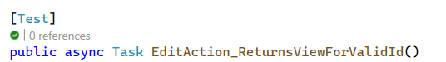

* **Test Setup (Arrange)**

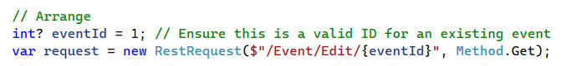

* **Executing the Request (Act)**

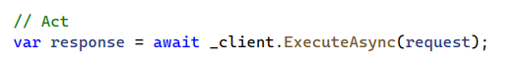

* **Verifying the Response (Assert):**



### Testing "Edit" Action (POST Request) (Successful Edit)

* **Arrange Phase: Test Setup**

*Fetching the Event:* Initially, you retrieve an **existing event by its eventId** (in this case, 6) to simulate editing an existing record. This step mimics **loading an event's current details to populate the form initially**.

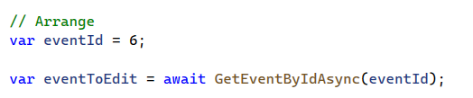

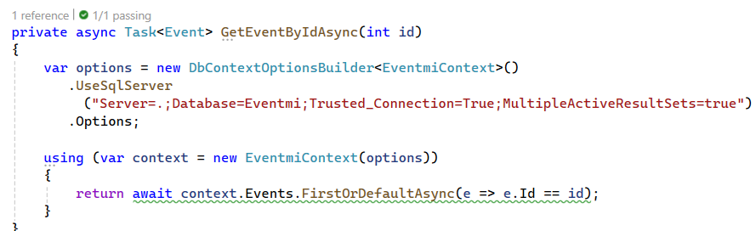

*Updating the Event Model:* **Create an EventFormModel** **object**, representing the **form data that will be submitted**. This model is **populated with the existing event's details** but with an **updated name** to simulate the user changing the event's name in the edit form.

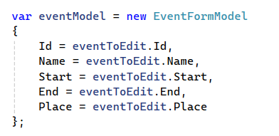 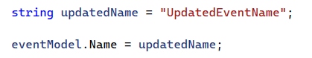

*Preparing the Request:* **RestRequest is prepared** to **send to the /Event/Edit/{eventId} endpoint**, using the **POST** method. The **content type is set to application/x-www-form-urlencoded**, mimicking a typical form submission from a web browser. The updated event details are added as parameters to the request.

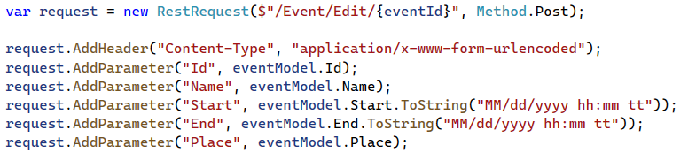

* **Act Phase: Executing the Request**

*Sending the Request:*The prepared request is sent asynchronously using RestSharp's ExecuteAsync method. This **simulates the user clicking the submit button on the edit form**



* **Assert Phase: Verifying the Outcome**

*Checking the Response:* The test verifies that the server's response has a status code of **OK (HTTP 200)**. In a real-world scenario, you might expect a redirect status (like 302) after a successful edit, depending on how your application is designed to respond. For this test, an OK status indicates the request was processed successfully.



* **Verify the successful edit in your database using SQL Server Management Studio**

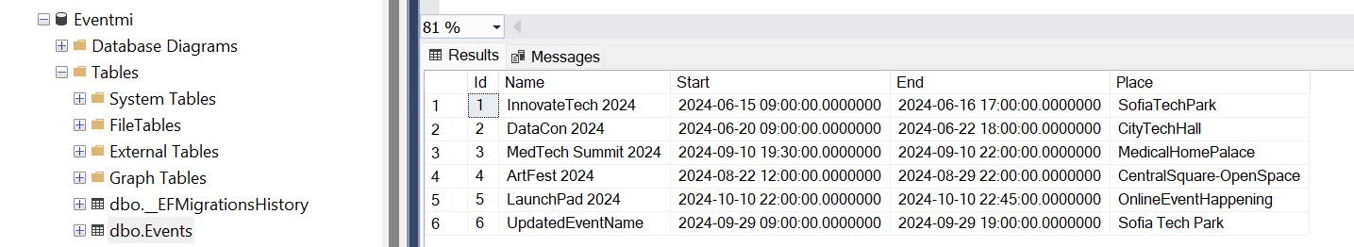

### Testing "Edit" Action (POST Request) (Different Scenarios)

* **ID Mismatch Scenario**

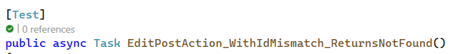

* + The method checks if the **id parameter matches the Id property of the eventModel**.

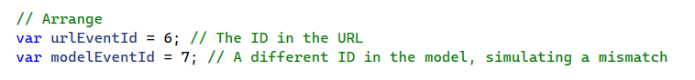

* + If they don't match, it **returns a NotFound result**
  + Ensure the method correctly handles cases where the id in the URL does not match the Id in the form data, potentially indicating a bad request or data tampering



* **Invalid Model Scenario**

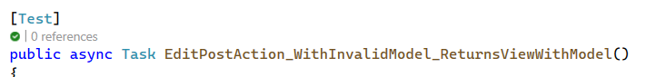

* + If **ModelState.IsValid** returns false, the **method returns the eventModel back to the view**, allowing the user to correct any errors

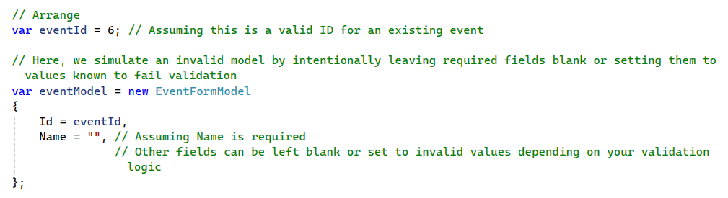

* + **Verify** the application **properly returns to the edit form with validation feedback** when submitted data fails model validation checks



### Testing "Delete" Action (POST Request)

